
MATHS METHODS 3 & 4
TRIAL EXAMINATION 2
SOLUTIONS
2017

SECTION A – Multiple-choice answers

- A 9. B 17. D
- D 10. E 18. C
- E 11. E 19. C
- C 12. A 20. A
- B 13. D
- E 14. A
- B 15. B
- E 16. D

SECTION A – Multiple-choice solutions

Question 1
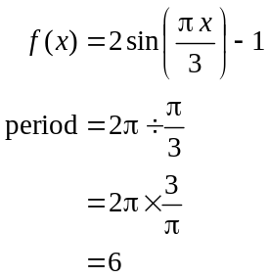
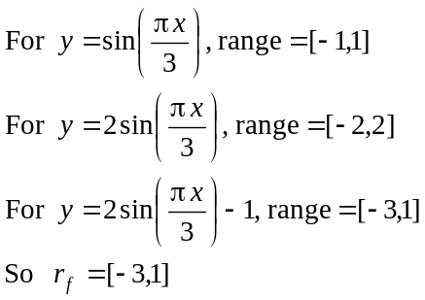
The answer is A.

Question 2

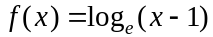
For the function f to be defined,
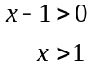
Note that the maximal domain of f is 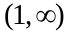 which is not offered in the options.
But if f were to have a restricted domain, then it could be 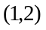. For all the other options, f is not defined. So 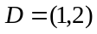
The answer is D.
Question 3
The period of the graph is 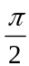.
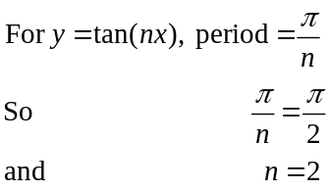
So we reject options A, B and C. The graph shown is that of a tan graph that has been reflected in the x or y-axis. Option E offers the case where there has been a reflection in the x-axis. So the required rule for f is 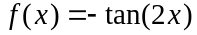
The answer is E.

Question 4
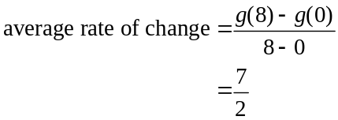
Note, if you put B as your answer you didn’t bracket the numerator of the fraction above when entering it in your CAS. If you obtained E, then you found the average value, not the average rate of change.
The answer is C.

Question 5
Function f is strictly decreasing over an interval if 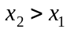 implies that 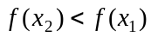.
This is the case for the interval 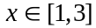.
Note that we have not been asked for the interval where the gradient of f is negative. Such an interval would not include the endpoints .
The answer is B.

Question 6
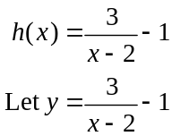
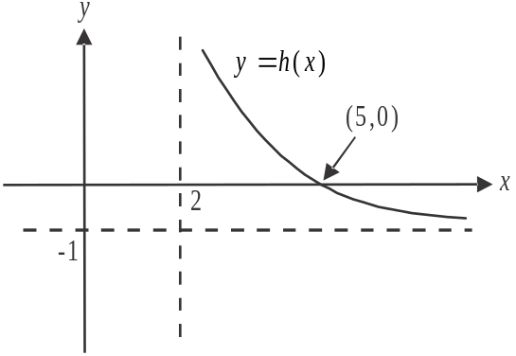
Swap x and y for inverse.
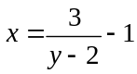
Solve for y using CAS.
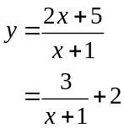
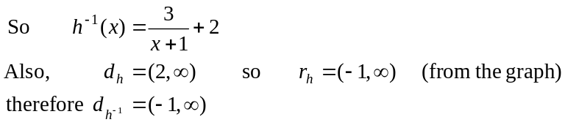
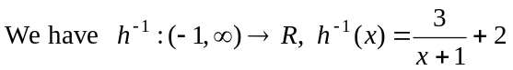.
The answer is E.
Question 7

Start by finding 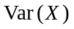.
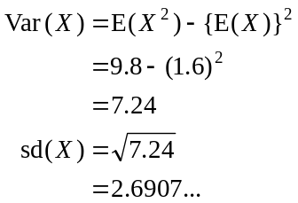
The closest answer is 2.69.
The answer is B.

Question 8

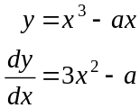
Stationary points occur when 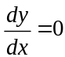.
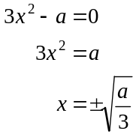
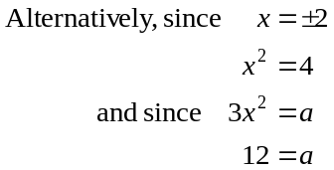
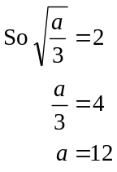
The answer is E.

Question 9

The right endpoint of f occurs at the point 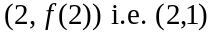.
So the horizontal line running through this right endpoint is 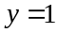.
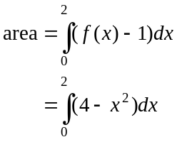
The answer is B.
Question 10
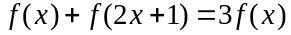
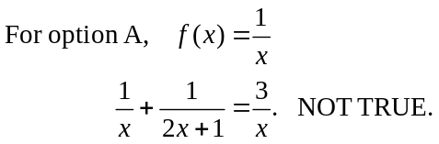
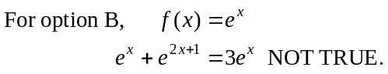
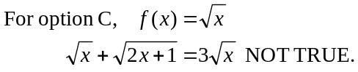
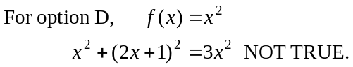
Option E must be true i.e. 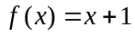
The answer is E.

Question 11
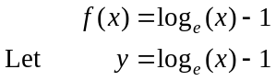
After a reflection in the y-axis, the rule becomes 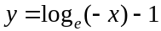.
After a dilation from the x-axis by a factor of , the rule becomes
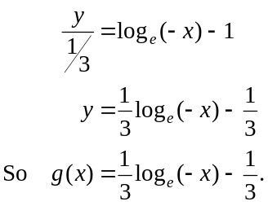
The answer is E.

Question 12
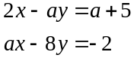
This system of equations can be expressed as the matrix equation
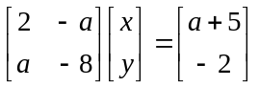
There are no solutions or infinitely many solutions
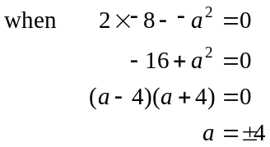
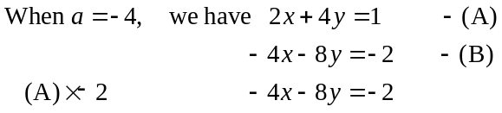
When there are infinitely many solutions.

The answer is A.

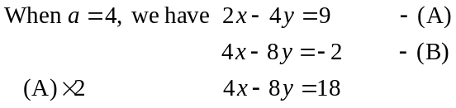
There are no solutions when .

Question 13
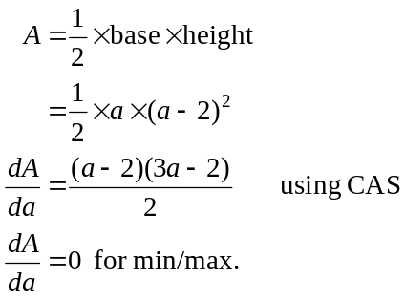
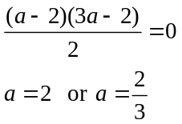
So 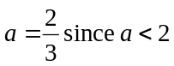.
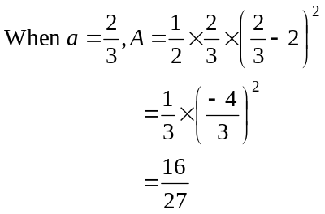
The answer is D.

Question 14
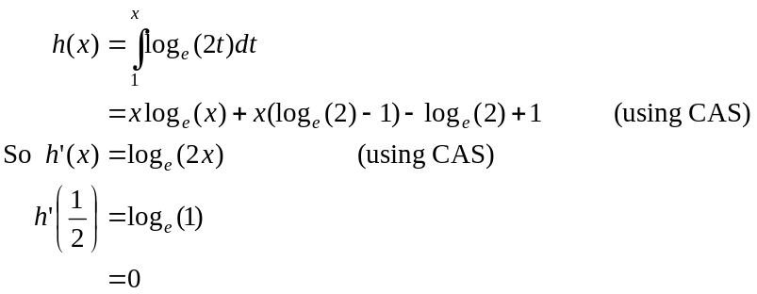
The answer is A.

Question 15
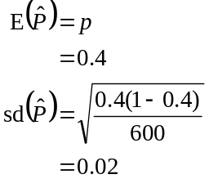
The answer is B.
Question 16

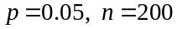
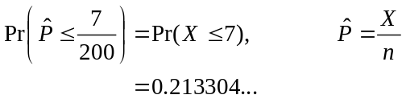
using binom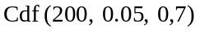
The closest answer is 0.2133.
Note that if you gave 0.1652, you used a normal approximation which the question asked you not to do.
The answer is D.

Question 17

Since f defines a probability density function, 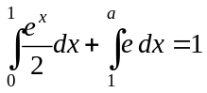.
Solve this equation for a using CAS.
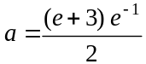
which can be written as
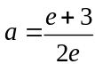
The answer is D.

Question 18

Method 1 – using a Karnaugh map

 | ready | not ready
OS | 5 | 20 | 25
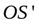 | 15 | 15 | 30
 | 20 | 35 | 55

The entries in bold are what we are given in the question and the others we can work out.
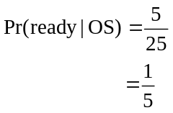
The answer is C.

Method 2 – using a tree diagram
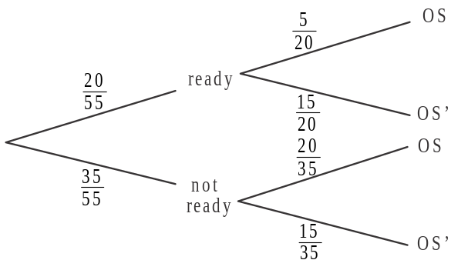

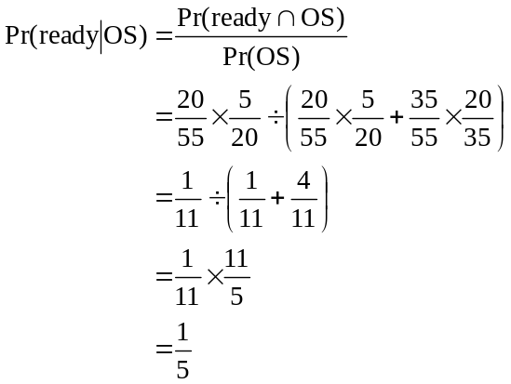
The answer is C.

Question 19
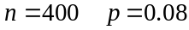
For the normal approximation, 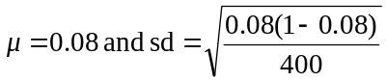
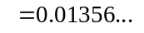
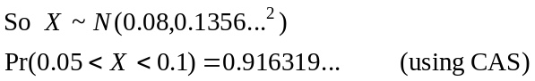
The closest answer is 0.9163.
The answer is C.

Question 20
The graph of f is
- reflected in the y-axis
- dilated by a factor of 2 from the x-axis
- translated 3 units down to become the graph of g.
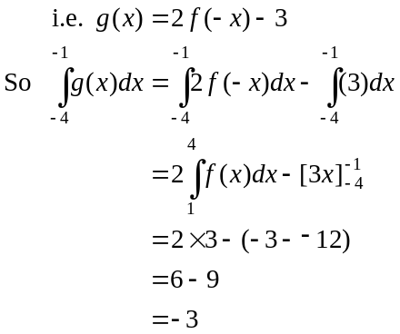
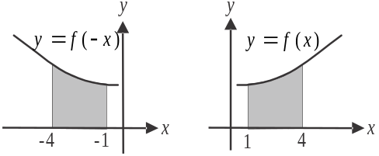
Note: 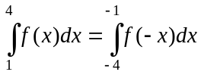
As an example:
The answer is A.
SECTION B

Question 1 (13 marks)

- From the graph, 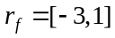. (1 mark)
- Define f on your CAS including the domain, i.e. 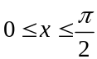. Point A lies on the x-axis.
Solve 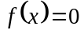 for x using CAS.
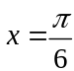 So A is the point 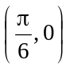. (1 mark)
- Using your CAS, find the derivative of 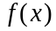 at the point where .
i.e. 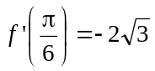 (1 mark)
Re-read the question!
So .
(1 mark)
- Using your CAS, solve 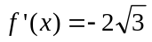 for x. (1 mark)
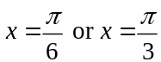
Point A occurs where .
Point B must therefore occur where 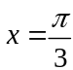 and 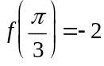.
Point B is 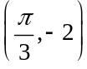.
(1 mark)
- The equation of the tangent at B is given by
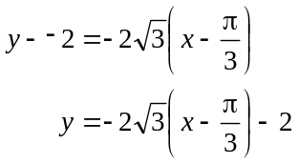
(1 mark)
This tangent intersects the x-axis when 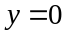.
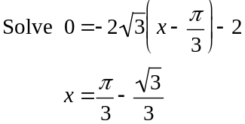
This point of intersection with the x-axis occurs to the left of point A and at point A,
.
Now 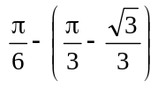
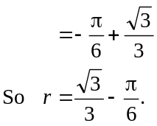
(1 mark)
f. Define g on your CAS. Note that it has the same rule as f but a different domain.
Solve 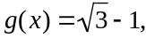 for x. (1 mark)
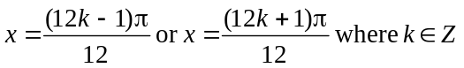.
(1 mark)

g. Let 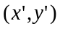 be an image point that lies on h.
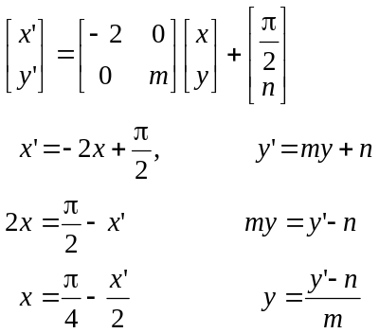

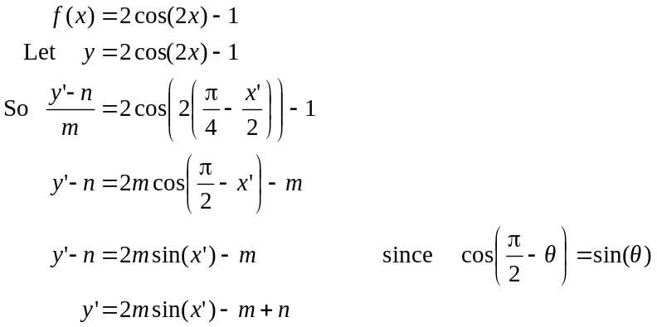
(1 mark)
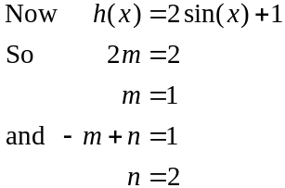
(1 mark)
(1 mark)
Question 2 (14 marks)

- i. 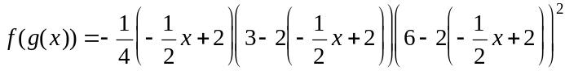 (1 mark)
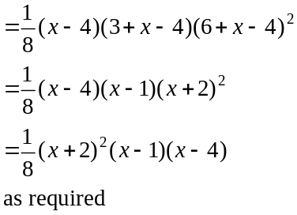
(1 mark)

  - 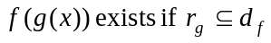
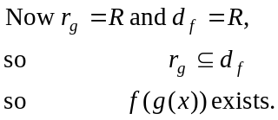
(1 mark)

- Define 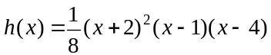 on your CAS.
Stationary points occur when 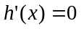.
Solve for x. (1 mark)
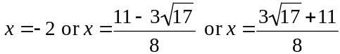
Re-read the question.
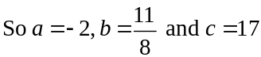.
(1 mark) for a and c
(1 mark) for b

- i. 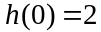
So A is the point (0, 2).
The gradient of the tangent at A is given by 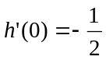 (using CAS).
Equation of tangent is
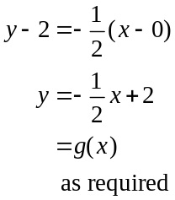
(1 mark)

  - Define 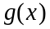 on your CAS.
To find the x-coordinates of points B and C, solve 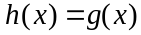 for x.(1 mark)
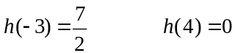
So B is the point 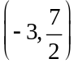 and C is the point 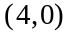.
(1 mark)
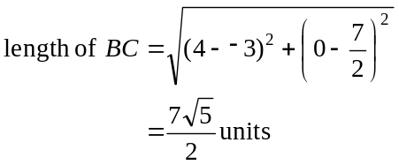
(1 mark)
Note that because we haven’t been asked to express our answer to a certain number of decimal places, we must leave it as an exact value.
Note also that the distance formula is not on the formula sheet so you must memorise it (in case you need it in Exam 1).

- i. Start by finding the equation of the line that passes through points D and X. This line has a gradient of 2 since it is perpendicular to the tangent with equation 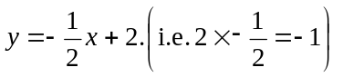.
It passes through the point D which is located at the point (−2, 0) (using working from part b.)
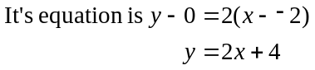
(1 mark)
To find the x-coordinate of X solve 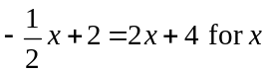.
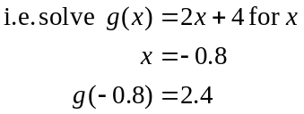
X is the point 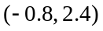.
(1 mark)

  - area of triangle BCD
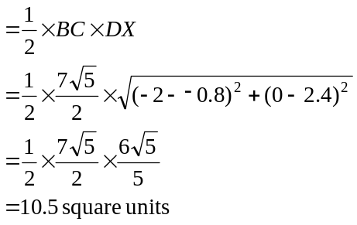
(1 mark)
(1 mark)

Question 3 (16 marks)

- i. Let X denote the number of parcels that require a signature at the delivery address.
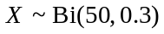 (1 mark)
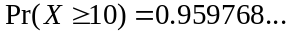 (Using CAS i.e. binom 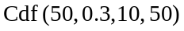
(1 mark)
  - 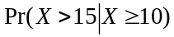
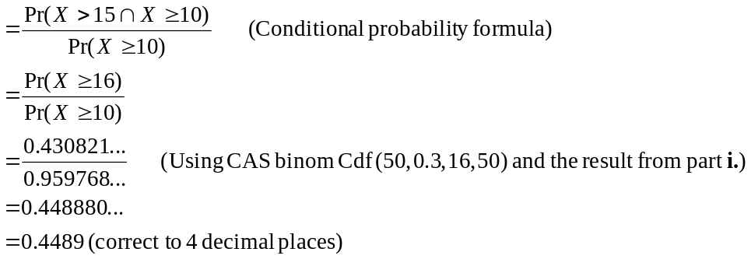 (1 mark)
(1 mark)

- Let Y denote the delivery time of a parcel.
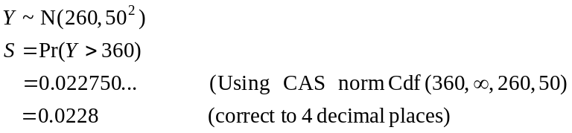
So 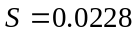 (correct to 4 decimal places as required)
(1 mark)

- Method 1
Let m represent more than 6 hours.
We require
(1 mark)
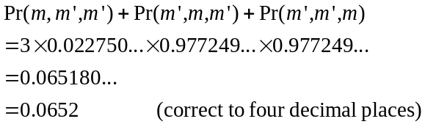
(1 mark)

Method 2
Let the number of parcels that took longer than 6 hours to deliver.
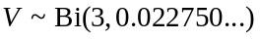
(1 mark)
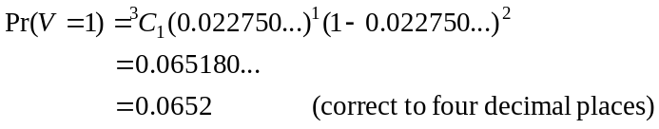
(1 mark)

- Let W denote the number of parcels that have a delivery time of more than six hours.
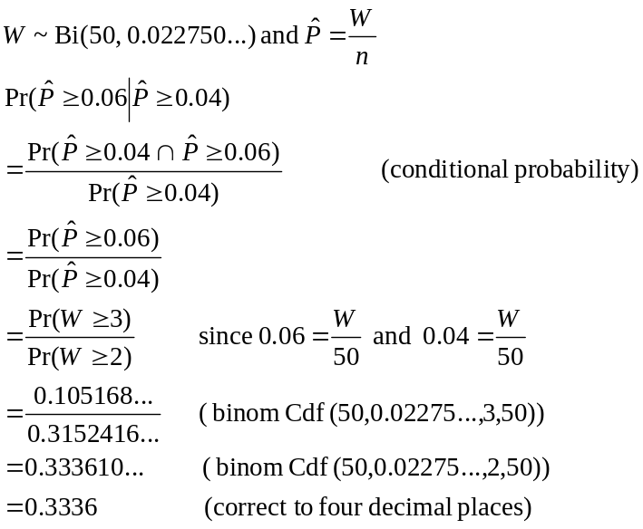
(1 mark)
(1 mark)
(1 mark)

- 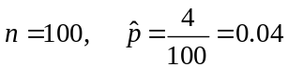
Using CAS, 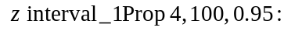
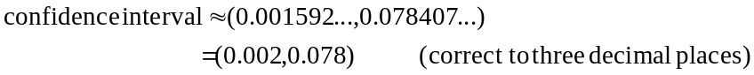
(1 mark)

- i. Start by defining f on your CAS.
Solve 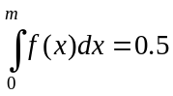 for m using CAS. (1 mark)
Note that we reject the other value of 83.3901… because it is outside the domain of f.
The median is 32.8 minutes correct to one decimal place.
(1 mark)

- This is a conditional probability question given that the delivery time must be at least greater than 20 minutes.
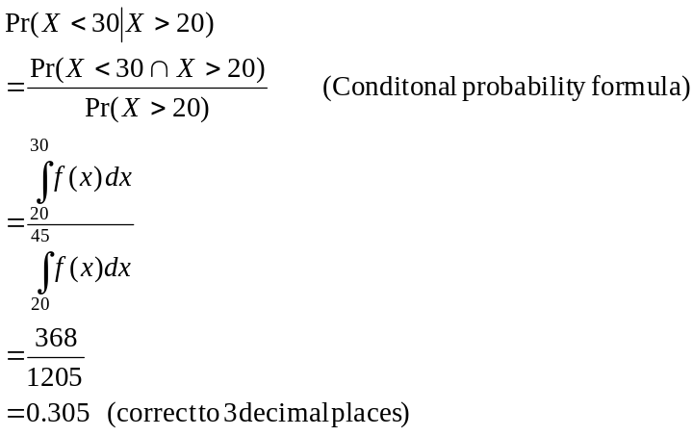
(1 mark)
(1 mark)
(1 mark)
Question 4 (17 marks)

- i. 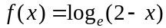
Let 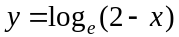
Since the graph of f is reflected in the y-axis, replace x with −x.
We have 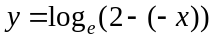
So, 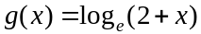.
(1 mark)

(1 mark)

  - Do a quick sketch.
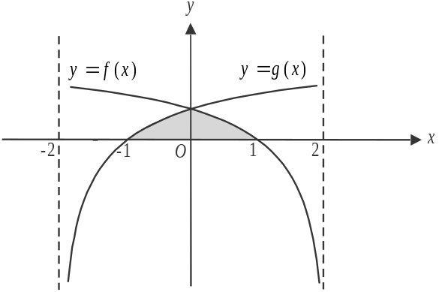
The required area is shaded.
Because the graphs of f and g
are symmetrical about the
y-axis,
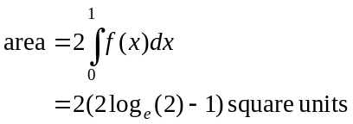
(1 mark)

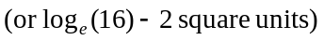

(Note – you must express your answer as an exact value because you have not been asked to approximate to a certain number of decimal places.)

- i. Define h on your CAS.
y-intercept occurs when
The y-intercept is 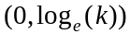 (1 mark)
x-intercept occurs when
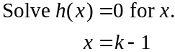
The x-intercept is 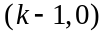.
(1 mark)

  - If 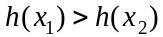
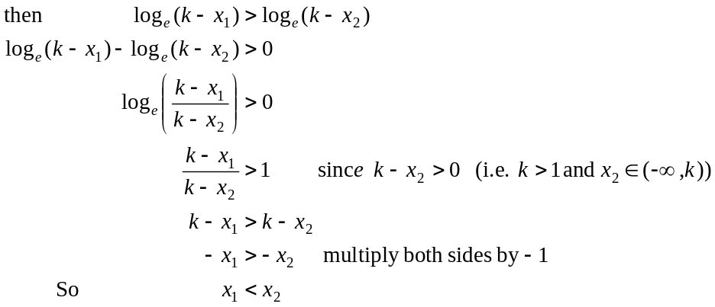
(1 mark)
(1 mark)
iii. Having already defined h, use your CAS to find the equation of the tangent
ie .
(1 mark)
iv. Method 1

From part iii, the equation of the tangent is 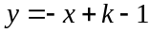.
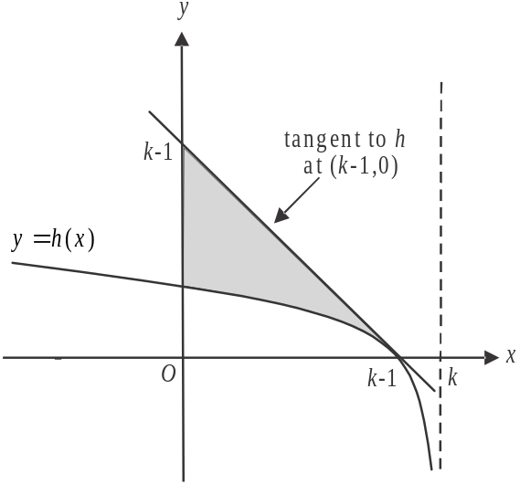

The gradient of the tangent is −1 so it will cut the y-axis at 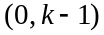.
Alternatively, the y-intercept of this tangent occurs when 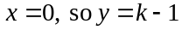.
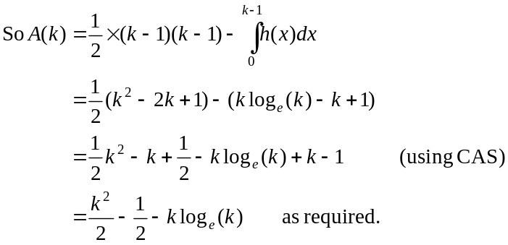
(1 mark)
(1 mark)

Method 2
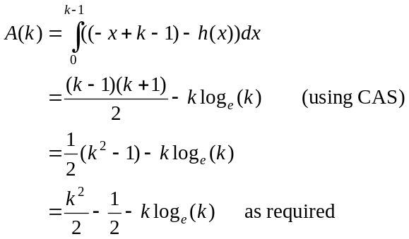
(1 mark)
(1 mark)
v. Solve 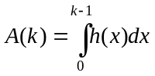 for k. (1 mark)
. (1 mark)
So (correct to 2 decimal places).
(1 mark)
- i. 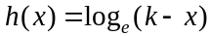
Let 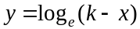
Swap x and y for inverse.
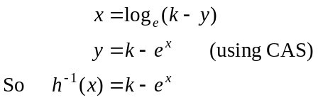
(1 mark)
From the graph of h shown earlier, 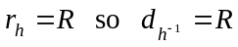.
(1 mark)

- Method 1
The tangent to h at the point has equation (from part b. iii.).
The gradient of this tangent is −1.
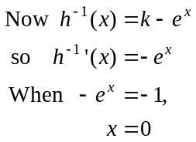
(1 mark)
So 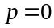.
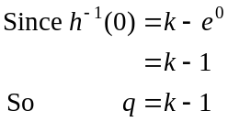
(1 mark)

Method 2 – graphically
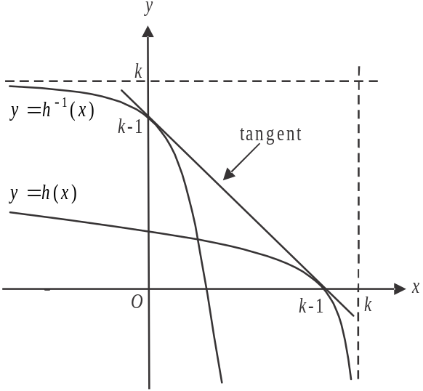

The graph of 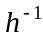 is a reflection of the graph of h in the line .
So the tangent to h at will be a tangent to at . (1 mark)

So 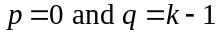 (i.e. answer the question!).
(1 mark)

